# SDLC_9_Winterfell-LibraryManagement

**Introduction**

* Searching for a book in a real large library is a very tedious process and keeping manual method of tracking book transactions is even more tedious. So through this program we have come up with a solution which can ease these tasks by implementing a “C program”. In this program we as a user can perform adding, searching the books and more importantly displaying the information of the books in the library.
* The library management is a project that manages and stores books information electronically according to student’s needs. The system helps both students and library manager to keep a constant track of all the books available in the library. It allows both the admin and the student to search for the desired book.

**Features of our system**

The main features of this application includes

* Simple & Easy to Use
* Faster retrieval of information
* Reduced workload of the library staff
* All details of the book will be available on a click

**Cost and Features with Time**

In order to determine the cost to develop library management system, a few aspects are to be considered first:

• Size of the App: More the features, more the cost.

• Number of Platforms: As the number of platforms are increased cost will also be increased significantly.

**Defining our system**

The Library Management System is an application for assisting a librarian in managing a book library in a university. The system would provide basic set of features to add books, user can delete the books from the list and searching the books, displaying the information of books.

**5W and 1H**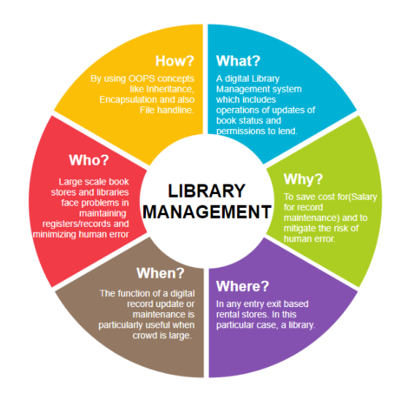

**SWOT Analysis**

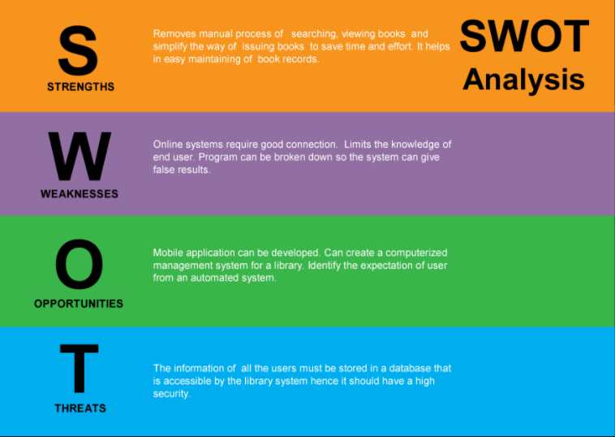

**Detail requirements**

**High Level Requirements:**

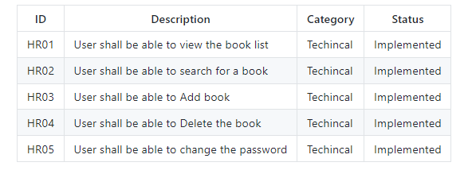

**Low level Requirements:**

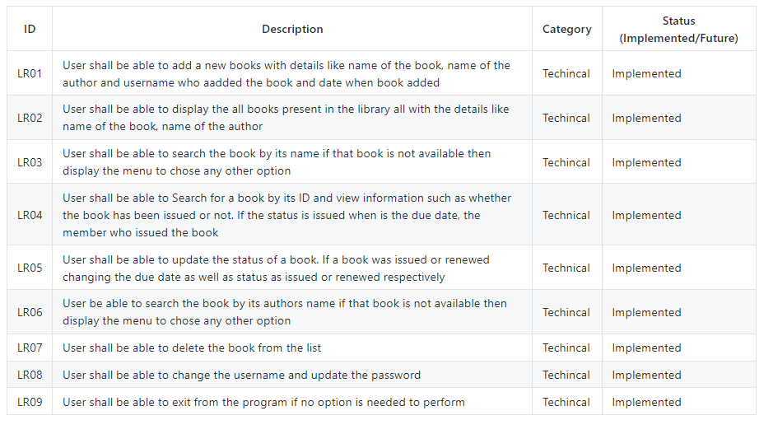

# Architecture

## High Level Design

## C:\Users\admin\Downloads\high level design.png

## Low Level DesignC:\Users\admin\Downloads\low level design.png

### Process Flow Diagram

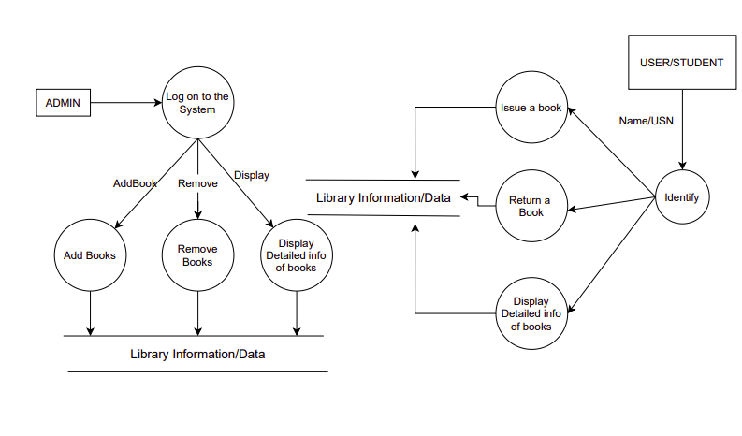

Use Case Diagram

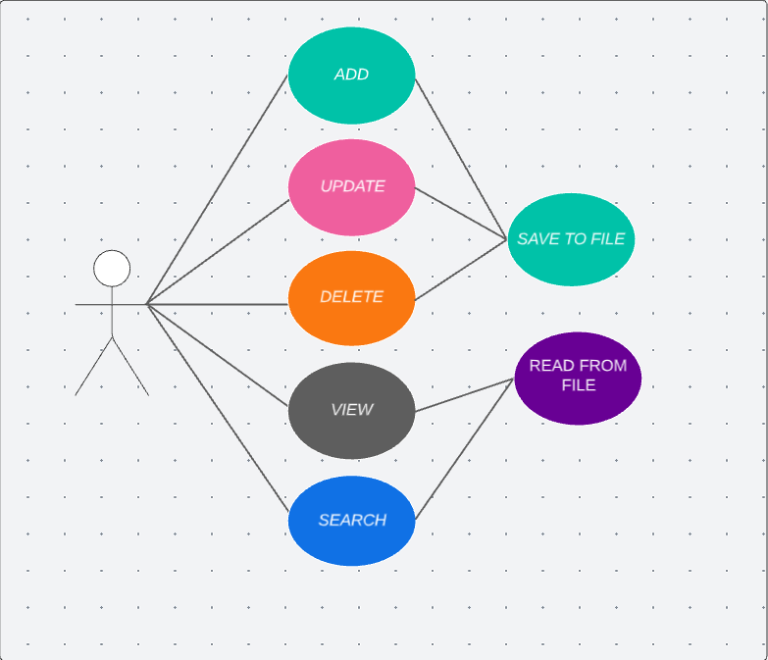

### Activity Diagram

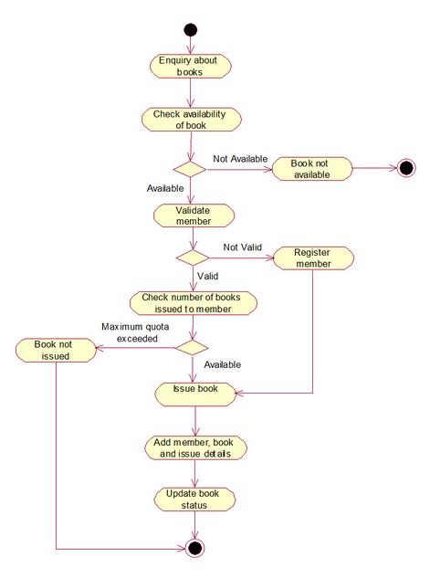

### Architecture Diagram

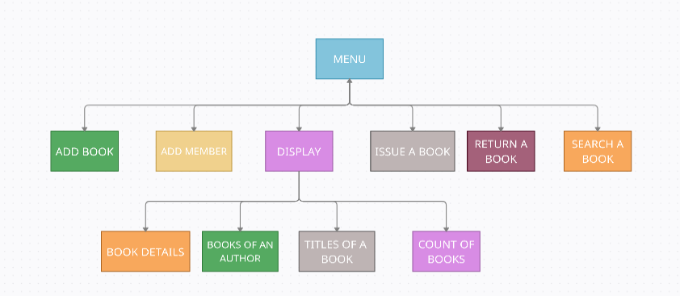

# TEST PLAN:

## High level test plan

## C:\Users\admin\Downloads\high level test plan.PNG

## Low level test plan

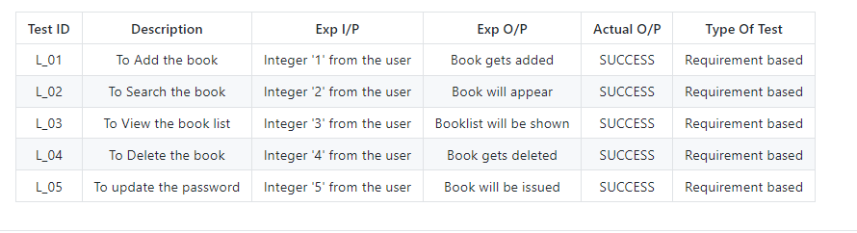

# Results:

# Add books

# addbook.PNG

# Search books

# Search.PNG

# View books

# view.PNG

# Update password

# updatepass1.PNG

# Video Link:

# https://github.com/BhavanSekar/SDLC_9_Winterfell-LibraryManagement/blob/main/5_Images/winterfell.mp4